Angular CLI stands for Angular Command Line Interface. As the name implies, it is a command line tool for creating angular apps. It is recommended to use angular cli for creating angular apps as you don't need to spend time installing and configuring all the required dependencies and wiring everything together.

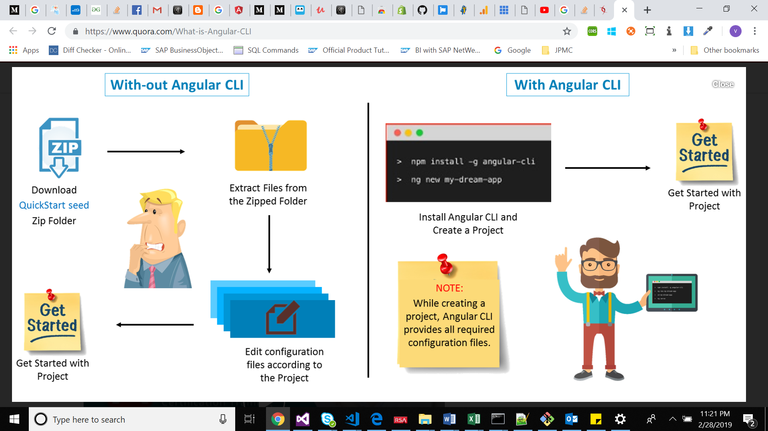

* Install [***node.js***](https://nodejs.org/en/download/) first if not already install (which I think you probably would have downloaded)
* Open the node.js command prompt and issue the command:

**>> npm install -g @angular/cli**

**Note:**The -g flag in the above command signifies the fact that the ng-cli is being installed in a global scope.

* If you want to check out the latest version of angular cli, modify the above stated command as:

**>> npm install @angular/cli@latest**

Now, let me list out few commands for you, which will come handy while creating angular projects:

**1.)Creating New Project: *ng new****<project-name>*

**ng new** allows you to generate a new angular project with all the boilerplate files already generated for you.

<https://alligator.io/angular/httpclient-interceptors/>

Error Handling Techniques in angular:

<https://scotch.io/bar-talk/error-handling-with-angular-6-tips-and-best-practices192>

https://medium.com/@aleixsuau/error-handling-angular-859d529fa53a